Requirements Definition

Hu$hBidz

1. **Introduction and Context**

This project aims to build a system for running an auction at a school or church activity. Traditionally, during an auction at one of these venues, there is a silent auction held first. The silent auction typically ends when the live auction begins.

In the silent auction, bids are written on a sheet of paper that is commonly placed before or next to the item. At the predetermined end of the auction, the highest listed bidder wins the item. This project aims to replace paper voting with a mobile phone system so that people can know what they’ve spent so far and will also help tally the results at the end of the night. Knowing how much they have spent immediately after the silent auction ends is beneficial for the bidders before they bid on live auction items.

A live auction is hosted by an auctioneer in real time, and is held before an audience of bidders. The project will include a way for an administrator to enter the final item price and winner into the system via PC so that results can be accessed by the users immediately. The administrator can then generate a final report at the end of the auction event with a list of all item winners and their charges or balances.

In summary, the auction system will be for managing a live event, not running an online auction. The system will support both a silent auction and a live auction and be capable of running on a PC (for an administrator) as well as iOS and Android mobile devices.

1. **Users and their Goals**

2.1.1 As an Admin, I want to start the timer

2.1.2 As an Admin, I want to see the data

2.1.3 As an Admin, I want to list items

2.2 As a timer, I end the auction

2.3.1 As a buyer, want to join the auction

2.3.2 As a buyer, I want to see bid data

2.3.3 As a buyer, I want to see updates

2.3.4 As a buyer, I want to bid on item

2.3.5 As a buyer, I want to list items

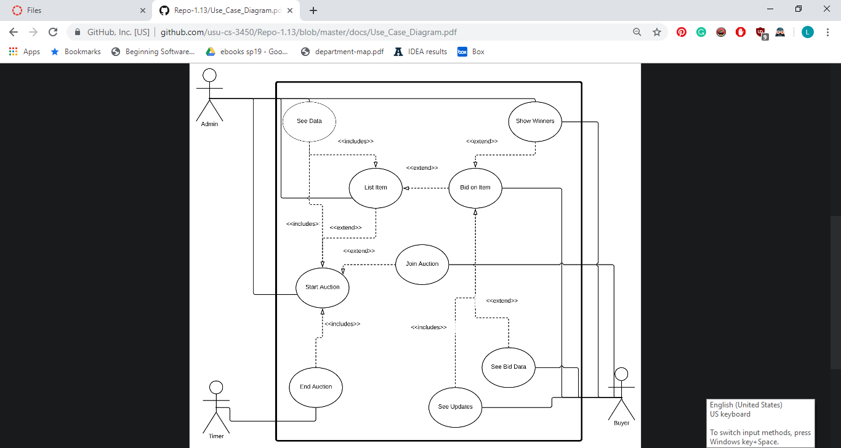2.3.6 As a buyer, I want to show winners

1. **Functional Requirements**

3.1 Admin must be able to…

3.1.1 Add items to an auction (setup)

3.1.2 Add bidders to an auction (registration process)

3.1.3 Start auction (time based ok)

3.1.4 End a silent action (time based ok)

3.1.5 Enter live item winner

3.1.6 Show all winners, with name, bidding number, items won, total cost

3.2 Users must be able to…

3.2.1 Bid on a silent item

3.2.2 List items I'm bidding on

3.2.3 List winning (or won) items with total price

1. **Non-functional Requirements**

The program shall support 300 concurrent users.

The application shall be platform-independent.

Display units shall be in whole dollar increments.

Project will be completed by December 1, 2019.

Users shall be assigned a unique identifying integer (bidder #) upon registration

1. **Future Features**

Item History Kahoot-live bidding

User profiles/IDs Track history of instances

Timer for each item Catalog/Grid view

Payment/code system Function on web, IOS and Android

Item Search with Location services

Notifications (when winning/outbid)

Current total winning bids balance

QR codes for items

1. **Glossary**

Product Backlog - a list of the new features, changes to existing features, bug fixes, infrastructure changes or other activities that a team may deliver in order to achieve a specific outcome.

Repository - a central location in which data is stored and managed

Scrum - a framework for project management that emphasizes teamwork, accountability and iterative progress toward a well-defined goal

Spiral Process - a systems development lifecycle (SDLC) method used for risk management that combines the iterative development process model with elements of the waterfall mode

Sprint - a set period of time during which specific tasks must be completed

Time-box (scheduling) - a previously agreed period of time during which a person or a team works steadily towards completion of some goal